Step 1: Open GitHub and log into your account. Search account irfatihaa and go to repository E-DPPR.

or;

Copy and paste the link: <https://github.com/irfatihaa/E-dppr>

You will be navigated to the screen as in below.

Step 2: Click on Code and Download Zip.

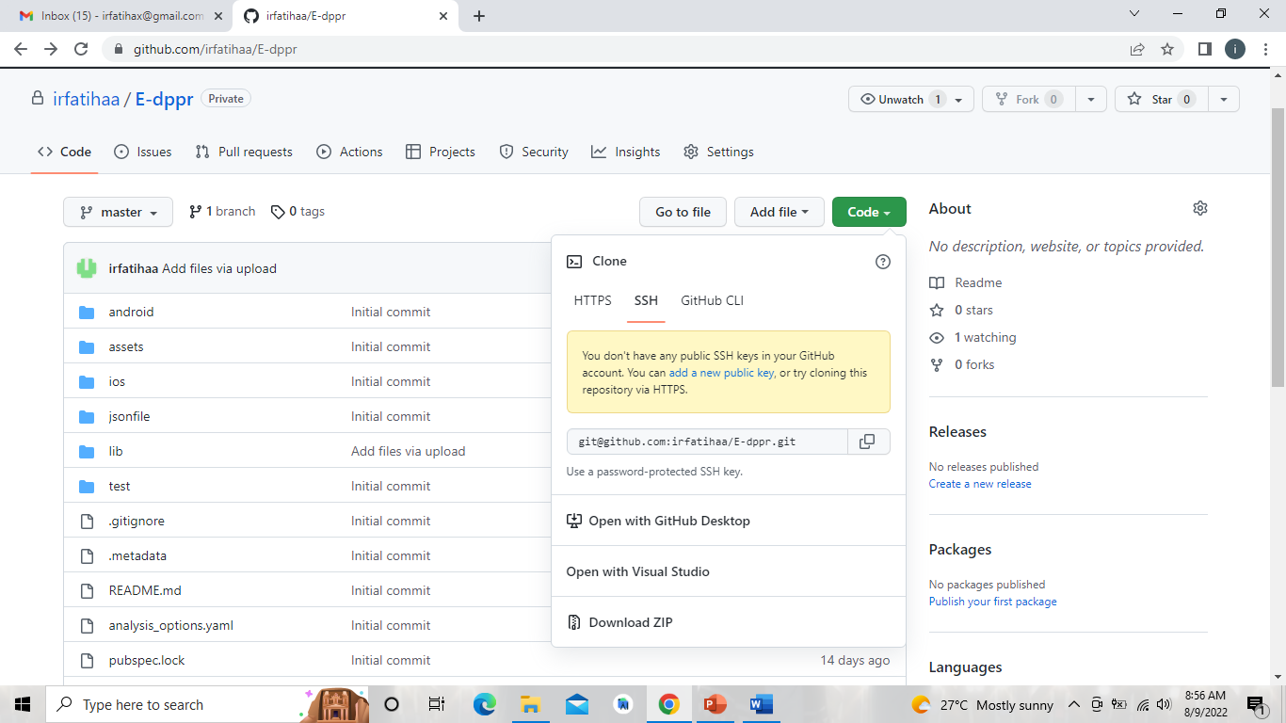

Figure 1: GitHub interface

Step 3: Open the Zip File and Extract. Put the folder either in C: or D:

Step 4: Open Android Studio. Click Open and select the folder (the downloaded zip on Step 3). The folder should be have Android Studio logo (green) to able to properly open. Refer to Figure 2 for example, Digital_DPPR-master and Flutter_UI-third-version.

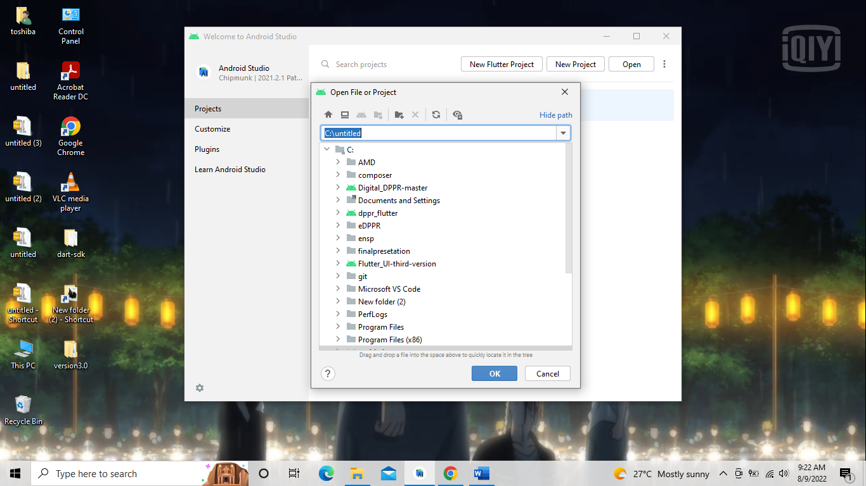

Figure 2: Android Studio

Step 5: Open File>Settings>Plugins to ensure that both Dart and Flutter are downloaded, installed and configured.

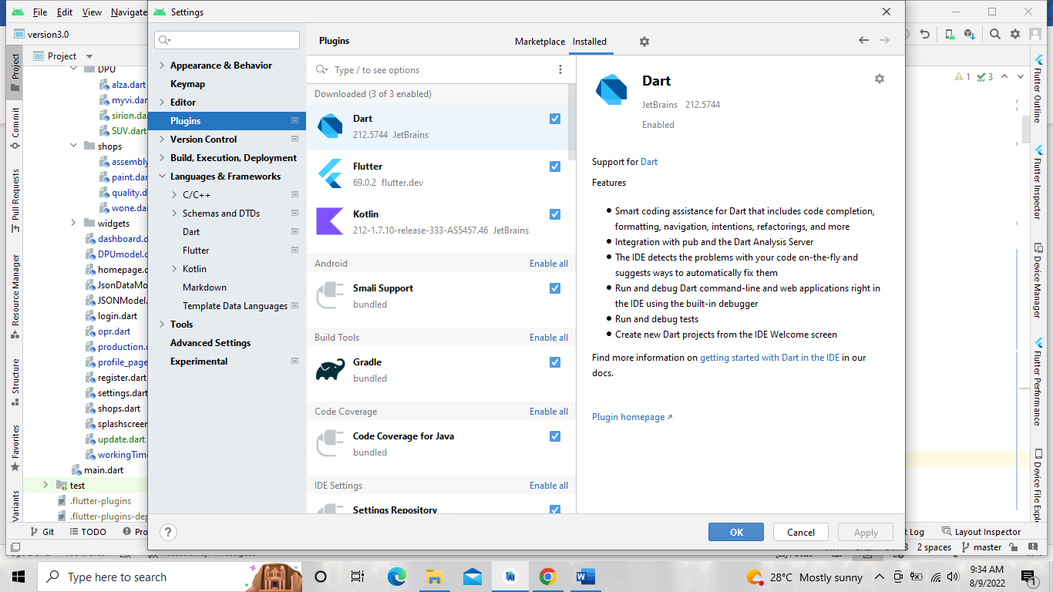

Figure 3: Settings in Android Studio

Step 6: Check the configuration for Dart in File>Settings>Languages & Frameworks>Dart. Ensure to tick on the Enable Dart Support and check the Dart SDK Path.

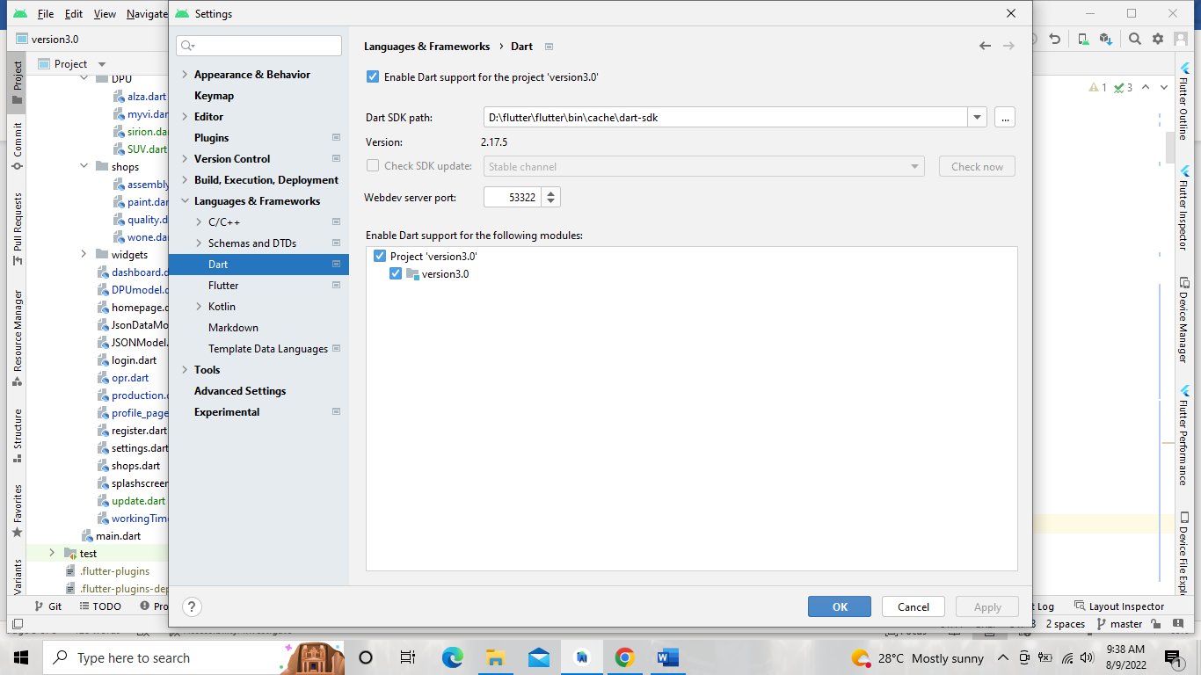

Figure 4: Dart Configuration

Step 7: Check the configuration for Dart in File>Settings>Languages & Frameworks>Dart. Check the Flutter SDK Path.

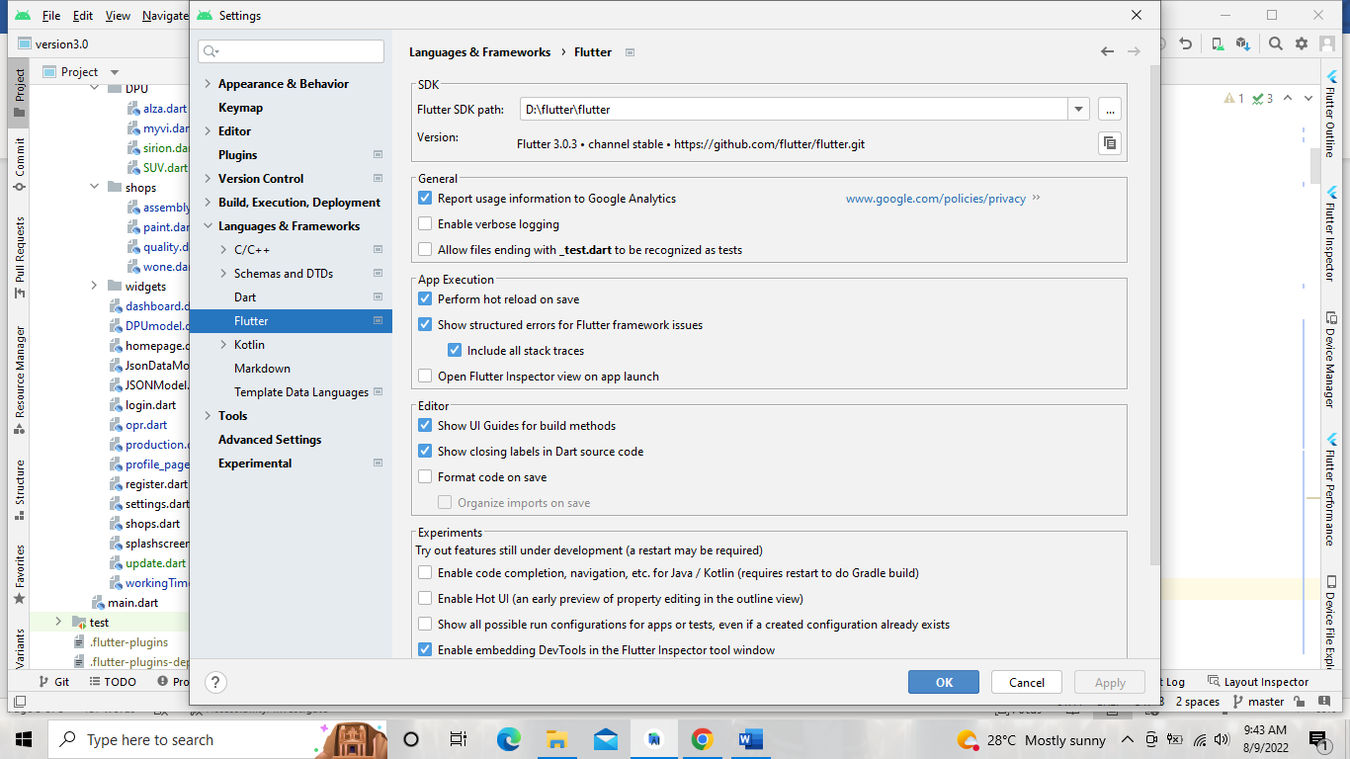

Figure 5: Flutter Configurations

Step 8:

To use physical Android device, ensure to setup the Developer Options in the mobile phones and allow the USB Debugging.

or;

To use Android Emulator, click on Device Manager and Create Virtual Device. Select suitable Android device, continue by downloading the Android API.

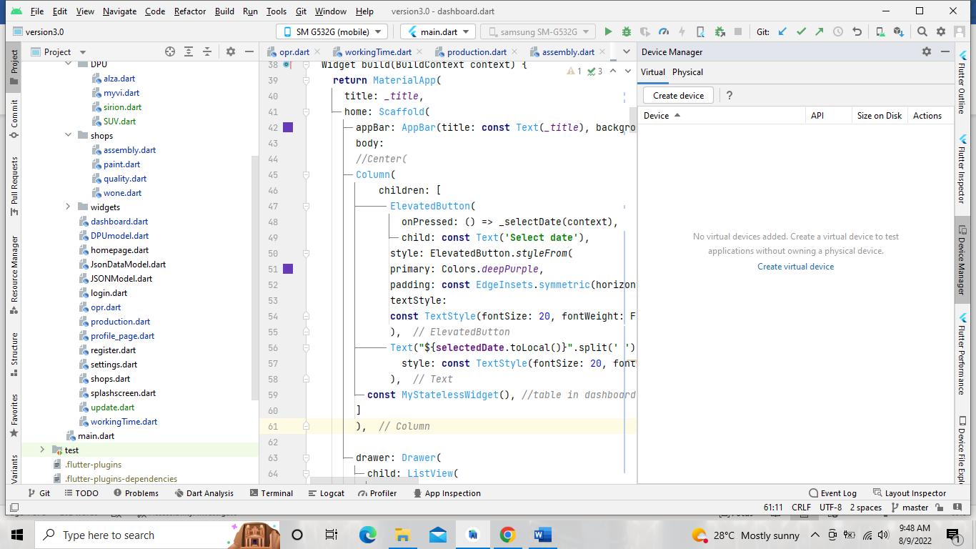

Figure 6: Device Manager Setup

Step 9: To run the project, click Run.

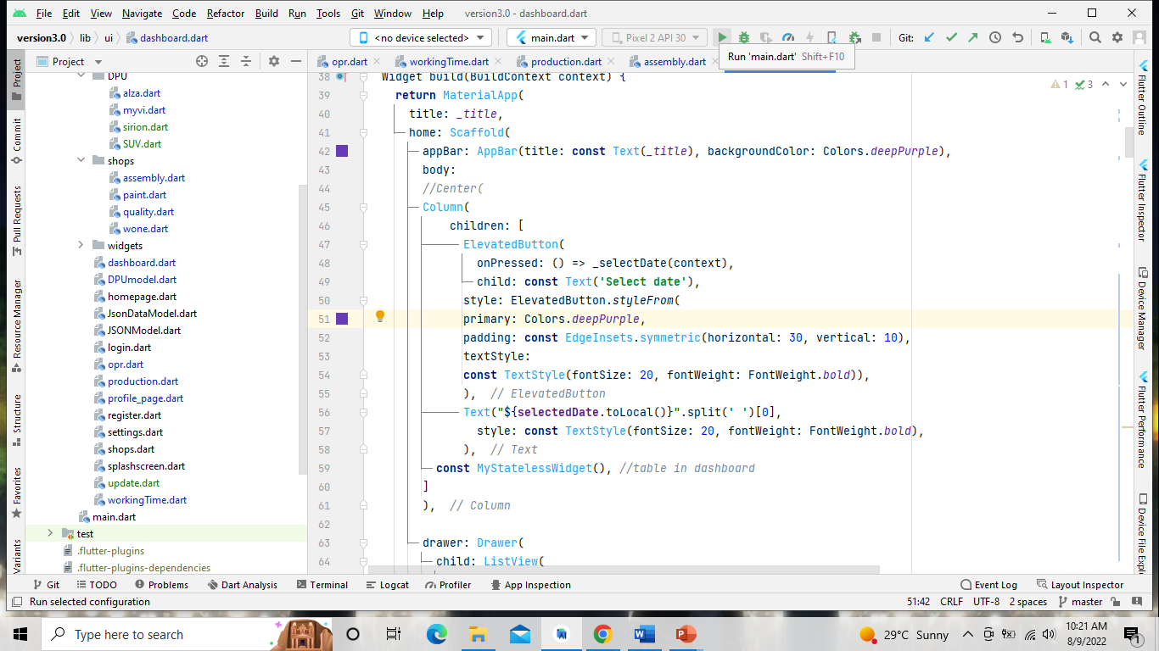

Figure 7: Run the project.